**AP LANGUAGE AND COMPOSITION  
DEBATE TOPIC 4: WIND FARMS: SOURCES**

**Name:______________________________________ Date:_____________________**

**Source A**

**Lake Winds construction complete; Ludington-area wind farm praised for boosting Mason County**

Published: Friday, September 21, 2012, 3:41 PM Updated: Friday, September 21, 2012, 3:41 PM

By Dave Alexander | [dalexan1@mlive.com](mailto:dalexan1@mlive.com) | Muskegon Chronicle | © MLive.com. All rights reserved.

LUDINGTON, MI – There was plenty to celebrate Friday when Mason County leaders gathered with Consumers Energy officials and Michigan utility regulators to recognize the completion of construction on the Lake Winds Energy Park.

Consumers Energy and White Construction have completed assembly of the 56-turbine, 1.8 megawatt in southern Mason County. The public utility’s first wind farm will begin operating sometime in November after testing and grid connections are completed by wind turbine supplier Vestas of North America.

The celebration at the Lincoln Hills Golf Club just north of Ludington was about a more than $250 million investment in Mason County’s Riverton and Summit townships, more than 151,000 worker hours so far for construction, a $7 million payroll and more than $9 million spent with local vendors.

“This is very important to us,” said Consumers Energy President and CEO John Russell. “This is our company’s first wind farm after 125 years. Our company believes in renewable energy. It is clean, reliable and affordable for Michigan.”

The past five years of development have not been easy as a small but vocal group formed to oppose the commercial wind farm that can be seen along U.S. 31 between Ludington and Pentwater. But now that the turbines are in place, public acceptance is growing, according to Kathy McLean, president of the Ludington & Scottville Chamber of Commerce.

“The community reaction has been positive,” McLean said after the construction completion ceremony. “Even those who were skeptical are finding them more attractive than they thought. People are really embracing the energy park.”

No one is a bigger cheerleader for the Lake Winds Energy Park than George Sadler, owner of a 300-acre farm in Riverton Township in the middle of the wind park.

“I find them just perfect,” Sadler said of the turbine constructed in July on the land farmed by his son George. “I’d have more on our land if they would give them to us.”

McLean said the ongoing Lake Winds construction has been a huge boost to the Ludington-area economy. Restaurants and hotels not only had one of their best tourism summer seasons this year but Lake Winds business have given some owners a record year, she said. The 56 Lake Winds Vestas turbines are 312 feet high at the hub with rotor blades having a 328-foot diameter.

And the wind farm has not hindered tourism, a huge portion of the community’s economy, McLean said. Far from it, the wind farm drew more than 1,000 on special chamber tours of the construction sites.

“Lake Winds has not driven away tourism but has just brought more excitement and attention,” the chamber president said.

From a state perspective, Lake Winds Energy Farm with its 100.8 megawatts of new renewable electricity moves the state closer to its goal of having 10 percent of electrical generation coming from renewable sources as is mandated in Michigan’s 2008 landmark energy law.

“The number one renewable energy resource in Michigan is wind,” said John Quackenbush, chairman of the Michigan Public Service Commission. “Wind turbines are now part of the Michigan landscape.”

Quackenbush said wind energy brings hundreds of millions of dollars of investment to the state, provides an environmentally cleaner source of electricity and creates a new tax base for local communities.

Lake Winds is expected to provide $29 million in new revenues for Mason County governments over the next 20 years. On top of that, the construction of the wind farm created a $33 million boost to the local economy and $4 million annually in economic impact for the ongoing operation and maintenance of the wind turbines.

Finally, those gathered at Lincoln Hills Golf Club Friday paid tribute to the late Darren Owens, Consumers Energy’s construction manager for Lake Winds until his death July 29 in a motorcycle accident in southern Michigan. Wind turbine Unit 8 will be dedicated to Owens' service to the company.

**Source B**

This infographic details key findings from the 2011 Wind Market Report. | Infographic by Sarah Gerrity.

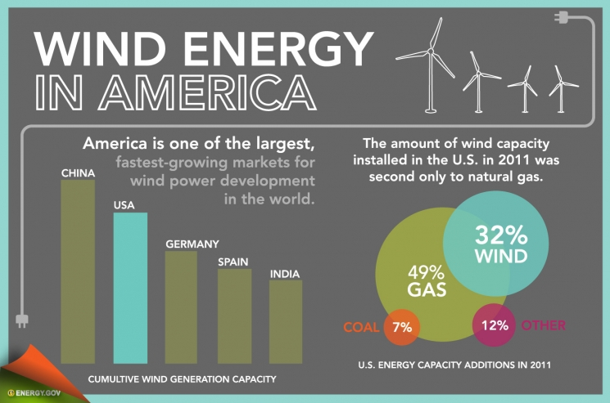

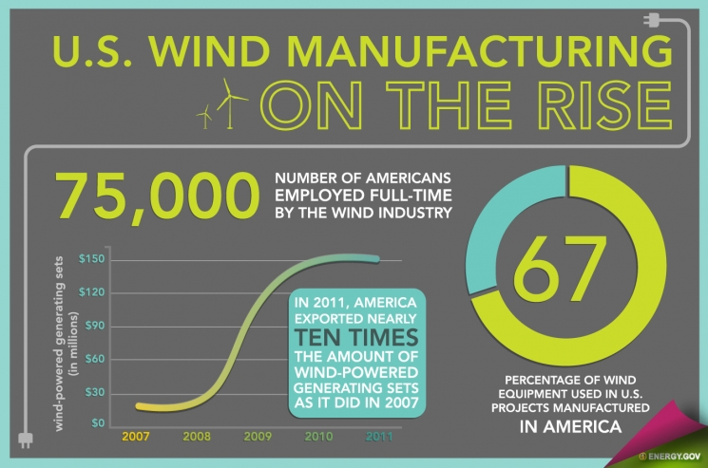

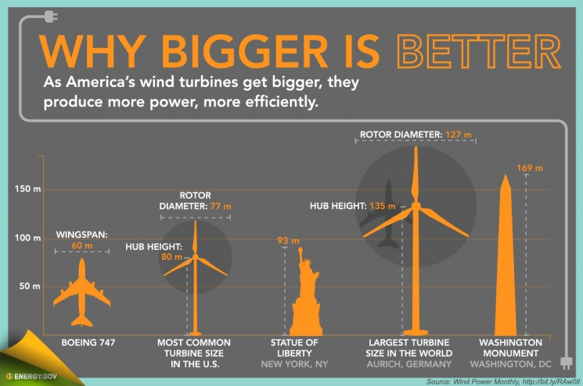

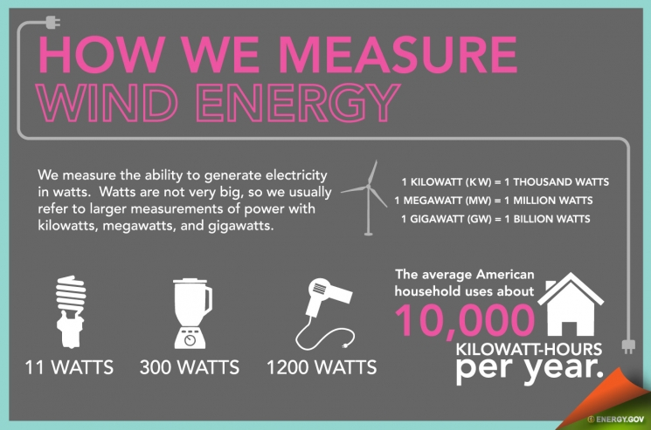

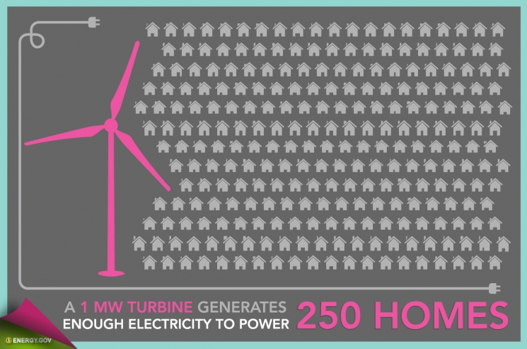

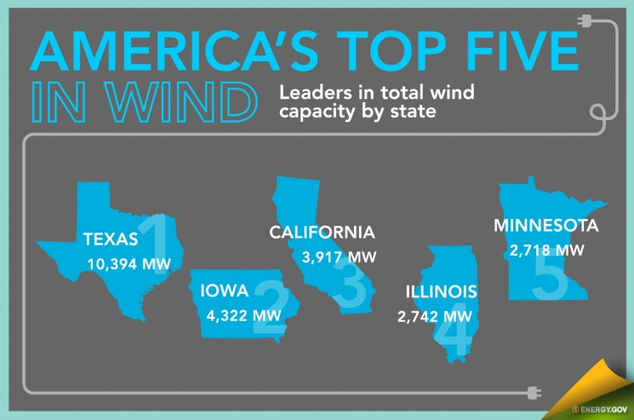

**Source C**

http://www.clean-energy-ideas.com/articles/advantages_and_disadvantages_of_wind_energy.html

© 2007 - 2012 www.clean-energy-ideas.com

**Advantages & Disadvantages Of Wind Energy**

There are a range of **advantages and disadvantages of wind energy** to look at, including the many problems associated with wind turbines.

In this day and age, the world needs to look at the different natural energy sources available to us. Global warming could be due our energy craving lifestyle, so we should look into more environmentally friendly energy sources.

**Advantages:**

* Wind energy is friendly to the surrounding environment, as no fossil fuels are burnt to generate electricity from wind energy.
* Wind turbines take up less space than the average power station. Windmills only have to occupy a few square meters for the base, this allows the land around the turbine to be used for many purposes, for example agriculture.
* Newer technologies are making the extraction of wind energy much more efficient. The wind is free, and we are able to cash in on this free source of energy.
* Wind turbines are a great resource to generate energy in remote locations, such as mountain communities and remote countryside. Wind turbines can be a range of different sizes in order to support varying population levels.
* Another advantage of wind energy is that when combined with solar electricity, this energy source is great for developed and developing countries to provide a steady, reliable supply of electricity.

**Disadvantages:**

* The main disadvantage regarding wind power is down to the winds unreliability factor. In many areas, the winds strength is too low to support a wind turbine or wind farm, and this is where the use of solar power or geothermal power could be great alternatives.
* Wind turbines generally produce allot less electricity than the average fossil fuelled power station, requiring multiple wind turbines to be built in order to make an impact.
* Wind turbine construction can be very expensive and costly to surrounding wildlife during the build process.
* The noise pollution from commercial wind turbines is sometimes similar to a small jet engine. This is fine if you live miles away, where you will hardly notice the noise, but what if you live within a few hundred meters of a turbine? This is a major disadvantage.
* Protests and/or petitions usually confront any proposed wind farm development. People feel the countryside should be left in tact for everyone to enjoy it's beauty.

**Overview Of The Wind Energy Advantages And Disadvantages**

So there we have the main advantages and disadvantages of wind power on the surrounding environment, and the general reliability of wind turbines.

**Source D**

[MasterResource](http://www.masterresource.org): A free-market energy blog  
October 24, 2012

**http://www.masterresource.org/2012/10/20-bad-things-wind-3-reasons-why/**

**Editor note: This is an updated version of a previous post at MasterResource: “**[Wind Spin: Misdirection and Fluff by a Taxpayer-enabled Industry](http://www.masterresource.org/2012/02/wind-spin/)” which was itself an update of **“**[Fifteen Bad Things About Wind Energy, and Three Reasons Why](http://www.masterresource.org/2010/09/15-bad-things-windpower/)**,” one of the two most read posts in the history of MasterResource.**

**Twenty Bad Things About Wind Energy, and Three Reasons Why**

Trying to pin down the arguments of wind promoters is a bit like trying to grab a greased balloon. Just when you think you’ve got a handle, it morphs into a different shape and escapes your grasp. Let’s take a quick highlight review of how things have evolved with wind merchandising.

**1** – Wind energy was abandoned well over a hundred years ago, as even in the late 1800s it was totally inconsistent with our burgeoning, more modern needs for power. When we throw the switch, we expect that the lights will go on – 100% of the time. It’s not possible for wind energy, by itself, to EVER do this, which is one of the main reasons it was relegated to the dust bin of antiquated technologies (along with such other inadequate energy sources as horse and oxen power).

**2** – Fast forward to several years ago. With politicians being convinced that Anthropogenic Global Warming (AGW) was an imminent catastrophic threat, lobbyists launched campaigns to favor anything that would purportedly reduce carbon dioxide. This was the marketing opportunity that the wind energy business needed. Wind energy was resurrected from the dust bin of power sources, as its promoters pushed the fact that wind turbines did not produce CO2 while generating electricity.

**3** – Of course, just that by itself is not significant, so the original wind development lobbyists then made the case for a quantum leap: that by adding wind turbines to the grid we could significantly reduce CO2 from those “dirty” fossil fuel electrical sources (especially coal). This argument became the basis for many states implementing a Renewable Energy Standard (RES) or Renewable Portfolio Standard (RPS) – which mandated that the state’s utilities use (or purchase) a prescribed amount of wind energy (“renewables”), by a set date.

Why was a mandate necessary? Simply because the real world reality of integrating wind energy made it a very expensive option. As such, no utility companies would likely do this on their own. They had to be forced to.http://www.masterresource.org/wp-includes/js/tinymce/plugins/wordpress/img/trans.gif For more on the cost, please keep reading.

**4** – Interestingly, although the stated main goal of these RES/RPS programs was to reduce CO2, not a single state’s RES/RPS requires **verification** of CO2 reduction from any wind project, either beforehand or after the fact. The politicians simply took the sales peoples’ word that consequential CO2 savings would be realized!

**5** - It wasn’t too long before utility companies and independent energy experts calculated that the actual CO2 savings were miniscule (if any). This was due to the inherent nature of wind energy, and the realities of necessarily continuously balancing the grid, on a second-by-second basis, with fossil-fuel-generated electricity. The frequently cited Bentek study ([How Less Became More](http://docs.wind-watch.org/BENTEK-How-Less-Became-More.pdf)) is a sample independent assessment of this aspect. More importantly, there has been zero scientific empirical proof provided by the wind industry to support their claims of consequential CO2 reduction.

**6** – Suspecting that the CO2 deception would soon be exposed, the wind lobbyists took pre-emptive action, and added another rationale to prop up their case: energy diversity. However, since our electricity system already had considerable diversity (and many asked “more diversity at what cost?”) this hype never gained much traction. Back to the drawing board….

**7** - The next justification put forward by the wind marketers was energy independence. This cleverly played on the concern most people have about oil and Middle East instability. Many ads were run promoting wind energy as a good way to reduce our “dependence on Middle Eastern oil.”

None of these ads mentioned that only about 1% of our electricity is generated from oil. Or that the US exports more oil than we use for electricity. Or that our main import source for oil is Canada (not the Middle East). Despite the significant omissions and misrepresentations, this claim still resonates with many people, so it continues to be pushed. Whatever works.

**8** – Knowing full well that the assertions used to date were specious, wind proponents manufactured still another claim: green jobs. This was carefully selected to coincide with widespread employment concerns. Unfortunately, when independent qualified parties examined the situation more closely, they found that the claims were wildly exaggerated. Big surprise!

Further, as attorney and energy expert Chris Horner has so eloquently stated:

There is nothing – no program, no hobby, no vice, no crime – that does not ‘create jobs.’ Tsunamis, computer viruses and shooting convenience store clerks all ‘create jobs.’ So that claim misses the point. Since it applies to all, it is an argument in favor of none. Instead of making a case on the merits, it is an admission that one has no such arguments.

See a very detailed critique of the jobs situation at [PTCFacts.Info](http://stopptcinfo.wordpress.com/job-claims-copy/). Listed there are TEN major reasons why using jobs as an argument is not appropriate or meaningful. Additionally there is a list of some 45 reports written by independent experts, and they all agree that renewable energy claims are based on numerous fallacies.

**9** – Relentlessly moving forward, wind marketers then tried to change the focus from jobs to “economic development.” The marketers typically utilized a computer program called JEDI to make bold economic projections. Unfortunately, JEDI is a totally inadequate model for accurately arriving at such numbers, for a variety of technical reasons. The economic development contentions have also been shown to be inaccurate, as they never take into account economic losses that result from wind energy implementation – for example [agricultural losses](http://www.fort.usgs.gov/Products/Publications/23069a/23069a.pdf) due to bat killings, and job losses due to higher electricity costs for factories, hospitals and numerous other employers.

Additionally, as with jobs, economic development in-and-of-itself has nothing to do with the merits of wind energy as a power source. Let’s say we have a transportation RES mandating that 20% of a state’s vehicles be replaced by horse power by 2020. There would be a LOT of “economic development” (making horse carriages and buggy whips, building horse barns, growing and shipping hay) that would result from such an edict. But would that be any indication that it is an intelligent, beneficial policy?

**10** – Along the way, yet another claim began making the rounds: that wind energy is low cost. This is surprisingly bold, considering that if that were really true, RES/RPS mandates would not be necessary. For some reason, all calculations showing wind to be “low cost” conveniently ignore exorbitant subsidies, augmentation costs, power adjusting (see next item), additional transmission costs, and so on. Independent analyses of levelized costs (e.g. from the EIA) have concluded that (when ALL applicable wind-related costs are accurately calculated) wind energy is MUCH more expensive than any conventional source we have.

**11** – A subtle (but significant) difference between wind energy and other conventional sources of electricity is in power quality. This term refers to such technical performance factors as voltage transients, voltage variations, waveform distortion (e.g. harmonics), frequency variations, and so forth. The reality is that wind energy introduces many more of these issues than does a conventional power facility. Additional costs are needed to deal with these wind-caused problems. These are rarely identified in pro-wind economic analyses.

**12** – When confronted with the reality that wind energy is considerably more expensive than any conventional source, a common rejoinder is to object to that by saying that once the “externalities” of conventional sources are taken into account, wind is less expensive than those conventional sources.

To gullible sheeple, this might make sense. But consider the following two points. First, externality analyses posited by wind zealots never take into account the true environmental consequences of wind energy (rare earth impacts [see below], human health effects, bird and bat deaths, the CO2 generated from a two million pound concrete base, etc.).

Second, the “externalities” for things like coal are always only the negative part. If these advocates want a true big picture calculation, then they need to also add in the **benefits** to us from low-cost coal-based electricity. Considering that coal played a major part in our economic success and improved health and living standards over the past century, such a plus factor would be enormous.

[BTW there is some evidence that the negative externalities (e.g. about coal related asthma claims) are exaggerated. What a surprise!]

**13** – A key grid ingredient is Firm Capacity**.** (A layman’s translation is that this is an indication of dependability.) Conventional sources (like nuclear) have a Firm Capacity of nearly 100%. Wind has a Firm Capacity of about 0%. Big difference!

**14** – Since this enormous Firm Capacity discrepancy is indisputable, wind energy apologists then decided to adopt the strategy that wind energy isn’t a “capacity resource” after all, but rather an “energy resource.” Surprisingly, this may be the first contention that is actually true! But what does this really mean?

The reality is that saying “wind is an energy source” is a trivial statement, on a par with saying “wind turbines are white.” Lightning is an energy source. So what? The fact is that your cat is an energy source too. In this Alice-in-Wonderland reality, connecting the cat to the grid (after heavily subsidizing it, of course), makes as much sense as does connecting puff power.

**15**- Wind marketers then hit on a new tactic: that we should use wind as it is a **plentiful resource**. This is a strategy based on a part truth: that we should be utilizing energy sources that are abundant, reliable, and low-cost. There are two major deficiences in this thinking.

First, abundant sources that are **not** reliable and that are **not** low-cost (i.e. wind energy), are a **net detriment** to our economy. Second, if they are really saying that abundance should be our primary focus, then they should be promoting nuclear power and geothermal energy. Both of these sources have something like a million times the available energy that wind does. Both of those are orders of magnitude more reliable than wind is. Both are lower cost when comparing the actual levelized cost of wind energy (e.g. Wind+ Gas).

**16**- One of the latest buzz-words is sustainability. One has to give these marketeers credit for being persistently imaginative. The truth about sustainability is:

a) It is totally hypocritical to have wind advocates attacking fossil fuels as unsustainable, when the wind business has an ENORMOUS dependency on fossil fuels for their construction, delivery, maintenance and operation. This [article](http://www.energybulletin.net/stories/2010-11-25/how-sustainable-renewable-energy) explains some of it.

b) Nothing is sustainable, as this [piece](http://wattsupwiththat.com/2011/12/22/nothing-is-sustainable/) accurately explains.

c) Wind energy is our LEAST sustainable [option](http://townhall.com/columnists/pauldriessen/2011/09/01/our_least_sustainable_energy_option/page/full/)!

**17** – A related pitch is that our adoption of wind energy will help us break “our fossil fuel dependence.” Guess what? The reality is that wind actually guarantees our perpetual dependence on fossil fuels! In addition to wind turbines’ dependence on fossil fuels for manufacture, delivery and maintenance, the only way wind energy can quasi-function on the grid is to have it continuously augmented by a fast responding power source – which for a variety of technical and economic reasons is usually gas.

It’s rather amusing that the same environmental organizations that support wind energy are also against shale gas. That’s like saying that you love Italian food but hate tomato sauce. The two are paired together like Fred Astaire and Ginger Rogers.

Realizing that their best defense is a good offense, some of these hucksters are now [contending](http://www.earthtimes.org/energy/should-we-embrace-wind-power/1807/) the inverse: that wind actually augments gas! So wind that generates electricity 25±% of the time is “augmenting” gas, which has to supply the 75±%! This immediately brings to mind the British army band playing “The World Turned Upside Down.”

**18** – The claim that wind energy is “green” or “environmentally friendly” is laugh-out-loud hilarious – except for the fact that the reality is not funny at all. Consider just one part of a turbine, the generator, which uses considerable [rare earth elements](http://climateerinvest.blogspot.com/2009/05/wind-why-rare-earth-metals-matter.html) (2000± pounds per MW).

The mining and processing of these metals has [horrific](http://www.dailymail.co.uk/home/moslive/article-1350811/In-China-true-cost-Britains-clean-green-wind-power-experiment-Pollution-disastrous-scale.html) environmental consequences that are unacknowledged and ignored by the wind industry and its environmental surrogates. For instance, a typical 100 MW wind project would generate approximately:

**a)** 20,000 square meters of destroyed vegetation,

**b)** 6 million cubic meters of toxic air pollution,

**c)** 33 million gallons of poisoned water,

**d)** 600 million pounds of highly contaminated tailing sands, and

**e)** 100,000 pounds of ***radioactive waste***. (See [this](http://fmso.leavenworth.army.mil/documents/rareearth.pdf), and [this](http://www.vetiver.org/ICV4pdfs/BA09.pdf), and [this](http://www.sdcleanwateralliance.org/RareEarthElements.html).)

**19** – Modern civilization is based on our ability to produce electrical POWER. Our modern sense of power is inextricably related to controlled performance expectations: when we turn the knob, we expect the stove to go on 100% of the time – not just on those wildly intermittent occasions when the wind is blowing within a certain speed range.

Underlying a lot of the wind lobbyists’ claims is a carefully crafted, implied message that there is some kind of wind energy “equivalency” to conventional sources. This assumption is the basis for such assertions that XYZ wind project will power 1,000 homes. Such claims are totally false. They are dishonest from several perspectives: the most obvious error being that XYZ wind project will NEVER provide power to any 1000 homes **24/7** (or really seconds or fractions of a second within each minute of each hour). It might not provide power for even one home 86400/1440/24/7.

Yet we see this same “equivalency” message conveyed even more subtly on EIA tables for levelized costs. Wind and conventional sources should not be on the same table, but they are (defended only by a small footnote). One useful analogy is to consider the cost, speed, reliability and load capacity of a single eighteen-wheeler truck in making daily interstate deliveries of furniture, heavy equipment or other large products. This semi-truck is equivalent to a nuclear plant.

In energy generation terms, the wind turbine equivalent is to attempt to replace the single truck with golf carts. How many golf carts would it take to equal the cost, speed, reliability and load capacity of a single eighteen-wheeler in making daily interstate deliveries? This is a trick question, as the answer is that there is **no** number that would work: not ten, not a hundred, not ten thousand, not a million. Exactly the same situation exists in the electricity sector: no number of turbines will ***ever*** equal the cost, reliability and output of one conventional electricity plant.

**20** – A close cousin of the prior illegitimate contention is that “The wind is always blowing somewhere, so spreading wind projects out will result in a combination that has a dependable output.” Like essentially all the wind industry mis-infomercials do, this bald assertion has a soothing, reassuring ring. But this marketing claim is unsupported by any empirical, real world evidence. For instance, in southeastern Australia about 20 wind [projects](http://ramblingsdc.net/Australia/WindSA.html#Operating_SA_wind_farms-Graph) are spread out over a single 1000± mile long grid. Yet the combined [result](http://windfarmperformance.info/documents/analysis/monthly/aemo_wind_201005_hhour.pdf) in no way even approximates the consistent dependable performance of our primary conventional sources.

Again, our modern society is based on abundant, reliable, affordable electric **power**. All these specious claims for wind energy are simply part of a long line of snake oil sales spiels – intended to fool the public and enable politicians to justify favoring special interests by enriching various rent-seekers (which will then return the favor via campaign contributions and other reelection support).

They get away with this primarily for three basic reasons.

**1** - Wind proponents are not asked to independently PROVE the merits of their claims before (or after) their product is forced on the public.

**2** -There is no penalty for making bogus assertions or dishonest claims about their product’s “benefits,” so each successive contention is more grandiose than the last.

**3** - Promoting wind is a political agenda that is divorced from real science. A true scientific assessment is a comprehensive, objective evaluation with transparent real world data – not on carefully massaged computer models and slick advertising campaigns, which are the mainstay of anti-science evangelists promoting political agendas.

So, in effect, we have come around full circle. A hundred-plus years ago, wind energy was recognized as an antiquated, unreliable and expensive source of energy – and now, after hundreds of billions of wasted tax and consumer dollars, we find that (surprise!) it still is an antiquated, unreliable and expensive source of energy. This is what happens when science is relegated to a back-of-the-bus status.

Paraphrasing Dr. Jon Boone:

Let’s see the real world evidence for the lobbyists’ case. I’m weary of these relentless projections, uncontaminated as they are by reality. In a nutshell, what these profiteers are seeking to do, through methodological legerdemain, is to make wind appear to be what it is not. This is a plot lifted out of Cinderella and her step-sisters, or the Emperor’s New Clothes. It’s really a story of class aspirations, but one that is bizarrely twisted: giving wind a makeover to make her seem fetching and comely when in fact she’s really a frog.

When you hear that wind opposition is all about NIMBYs, think about the above points, and then reflect on what NIMBY really means: The Next Idiot Might Be You.

But consider the sources. When a major turbine manufacturer calls a catastrophic failure like a blade falling off [component liberation](https://www.edockets.state.mn.us/EFiling/edockets/searchDocuments.do?method=showPoup&documentId=%7BCE6A8810-5F73-4455-A00C-063203CF1483%7D&documentTitle=20119-66248-01), we know we are in for an adventurous ride in a theme park divorced from reality.

See [**EnergyPresentation.Info**](http://www.slideshare.net/JohnDroz/energy-presentationkey-presentation) for more detailed explanations, including charts, photographs, entertaining graphics, and numerous references.

———

**John Droz, Jr., a physicist & environmental advocate, can e reached at** [**aaprjohn@northnet.org**](mailto:aaprjohn@northnet.org)**.**

**Source E**

(footnotes at end of article)

(Source: US Dept. of Energy, Energy Efficiency and Renewable Resources Information Center)

<http://www.windpoweringamerica.gov/pdfs/wpa/2011/wind_energy_benefits.pdf>

EERE Information Center

1-877-EERE-INFO (1-877-337-3463)

[www.eere.energy.gov/informationcenter](http://www.eere.energy.gov/informationcenter)

DOE/GO/102011-3226 • April 2011

Printed with a renewable-source ink on paper containing at least 50% wastepaper, including 10% post consumer waste.

Wind Energy Benefits

1. Wind energy is cost competitive with other fuel sources.

Power purchase agreements are now being signed in the range of 5 to 6 cents per kilowatt-hour,i a price that is competitive with new gas-fired power plants.ii Researchers expect continued cost reductions as the technology improves and the market develops.

2. Wind energy creates jobs.

Wind energy development creates thousands of long-term, high-paying jobs in fields such as wind turbine component manufacturing, construction and installation, maintenance and operations, legal and marketing services, transportation and logistical services, and more. In 2010, the wind sector invested $10 billion in the U.S. economy and employed 75,000 workers. In the same year, 31 manufacturing facilities opened or were announced. According to the American Wind Energy Association, employment in the wind industry’s manufacturing sector has increased from 2,500 jobs in 2004 to 20,000 in 2010, with an estimated additional 14,000 manufacturing jobs planned.iii (Policy decisions will affect this number.)iv

3. Wind energy is an indigenous, homegrown energy source that helps to diversify the national energy portfolio.

The United States is the world’s largest importer of oilv and natural gas.vi Our reliance on imports threatens our national economic security. Adding wind power to the energy mix diversifies the national energy portfolio and reduces America’s reliance on imported fossil fuels. In addition to bolstering the security of our national energy supply, wind energy stabilizes the cost of electricity and reduces vulnerability to price spikes and supply disruptions. With the expanded use of electric and plug-in hybrid vehicles, wind energy can also reduce our dependence on imported transportation fuels.

4. Wind energy can provide income for rural farmers and ranchers, as well as economic benefits to depressed rural areas.

Wind projects provide revenue to the communities in which they are located via lease payments to landowners, state and local tax revenues, and job creation. Even a utility-scale wind turbine has a small footprint, enabling farmers and ranchers who lease their land to developers to continue growing crops and grazing livestock. Achieving 20% wind energy by 2030 would provide significant economic benefits, including more than $8.8 billion in estimated property taxes and land lease payments between 2007 and 2030.vii Rather than paying for energy imported from other states, this money stays in the community.

5. Wind energy is an inexhaustible renewable energy source.

Wind energy is plentiful and readily available, and capturing its power does not deplete our natural resources. The Great Plains and offshore areas have tremendous untapped wind energy potential.

6. Wind turbines do not consume water.

Most electric power plants require water to operate, and water use in drought-stricken areas like the western United States is a significant issue. Producing electricity from the wind does not require water. Achieving a 20% wind energy by 2030 scenario would reduce cumulative water use in the electric sector by 8%, or 4 trillion gallons.viii

7. Wind energy is clean.

Electricity generated by wind turbines does not pollute the water we drink or the air we breathe, so wind energy means less smog, less acid rain, and fewer greenhouse gas emissions. A single 1-megawatt wind turbine can displace 1,800 tons of carbon dioxide (CO2) in 1 year (equivalent to planting 1 square mile of forest).ix Achieving 20% wind energy by 2030 would provide significant environmental benefits, such as avoiding approximately 825 million metric tons of CO2 emissions in the electric sector.x Because it is a clean energy source, wind energy reduces health care and environmental costs associated with air pollution.

8. Wind energy systems have low operating costs.

Wind energy systems have low operating expenses because they have no fuel cost. When large amounts of wind energy are added to the grid, additional generation may be required to accommodate wind energy’s variability, but the Utility Wind Integration Group concluded that system operating cost increases from wind variability and uncertainty amounted to only about 10% or less of the wholesale value of the wind energy and that there are ways to reduce these costs.xi The absence of fuel cost also protects consumers from fluctuating coal and natural gas costs.

9. Wind energy can be used in a variety of applications.

Wind turbines can be used in applications other than utility-scale wind farms. Community wind projects include turbines for schools, tribes, municipal utilities, and rural electric cooperatives. Small wind turbines, alone or as part of a hybrid system, can power homes, businesses, farms, ranches, and schools. Wind energy is perfect for remote applications, such as water pumping, ice making, powering telecommunications sites, and displacing diesel fuel in remote communities.

10. Wind energy is one of the most popular energy technologies.

Over the past 10 years, cumulative wind power capacity in the United States increased an average of 30% per year, slightly higher than the 28% growth rate in worldwide capacity.xii Wind energy was the most frequently installed energy technology on a capacity basis of any technology in the United States in 2008 and 2009.xiii

Because of all the benefits listed above and more, many opinion surveys show that the majority of people are in favor of wind energy. In Nebraska, a 2010 survey showed that 91% of respondents believe that the state should meet its electricity needs by using renewable energy such as wind power, and 79% of respondents favor requiring electric utilities to use renewable energy resources for at least 20% of the electricity they generate.xiv Finally, a national survey conducted in 2010 revealed that 89% of respondents believe that increasing the amount of energy the nation gets from wind is a good idea.xv

Despite wind energy’s numerous benefits, wind development is not appropriate everywhere. Individuals and communities should make informed decisions on local wind development. For more information, visit [*http://www.windpoweringamerica.gov*](http://www.windpoweringamerica.gov)

*————————————————————*

i American Wind Energy Association. Press release, January 24, 2011. http://www.americanwindenergyassociation.net/rn_release_01-24-11.cfm. Accessed March 12, 2011.ii Wiser, R.; Bolinger, M. (2010). 2009 Wind Technologies Market Report. 88 pp.; http://www.windandhydro.energy.gov/pdfs/2009_wind_technologies_market_report.pdf.

iii American Wind Energy Association. U.S. Wind Industry Annual Market Report 2010. http://www.awea.org.

iv In 2008, the U.S. Department of Energy published the report 20% Wind Energy by 2030: Increasing Wind Energy’s Contribution to U.S. Electricity Supply. The report includes a description of the significant job benefits that would result from a 20% scenario. An overview of the modeling utilized to derive the results is beyond the scope of this fact sheet, but the full report can be accessed at http://www.windandhydro.energy.gov/pdfs/41869.pdf.

v Central Intelligence Agency. The World Factbook. https://www.cia.gov/library/pub­lications/the-world-factbook/rankorder/2175rank.html?countryCode=&rankAnchorRow=#. Accessed March 11, 2011.

vi Central Intelligence Agency. The World Factbook. https://www.cia.gov/library/publi­cations/the-world-factbook/rankorder/2182rank.html. Accessed March 11, 2011.

vii 20% Wind Energy by 2030: Increasing Wind Energy’s Contribution to U.S. Electricity Supply. (2008). 248 pp.; http://www.windandhydro.energy.gov/pdfs/41869.pdf.

viii 20% Wind Energy by 2030: Increasing Wind Energy’s Contribution to U.S. Electricity Supply. (2008). 248 pp.; http://www.windandhydro.energy.gov/pdfs/41869.pdf.

ix American Wind Energy Association. Wind Energy Basics. archive.awea.org/news­room/pdf/Wind_Energy_Basics.pdf.

x 20% Wind Energy by 2030: Increasing Wind Energy’s Contribution to U.S. Electricity Supply. (2008). 248 pp.; http://www.windandhydro.energy.gov/pdfs/41869.pdf.

xi Utility Wind Integration Group, Utility Wind Integration State of the Art. (2006). http://www.uwig.org/UWIGWindIntegration052006.pdf.

xii Wiser, R.; Bolinger, M. (2010). 2009 Wind Technologies Market Report. 88 pp.; http://www.windandhydro.energy.gov/pdfs/2009_wind_technologies_market_re­port.pdf.

xiii Wind Power Today, 2010, Wind and Water Power Program. (2010). 32 pp.; http://www.windandhydro.energy.gov/pdfs/47531.pdf.

xiv Center for Rural Affairs. “Polling Shows Nebraskans Favor Renewable Energy.” http://www.cfra.org/NE-wind-poll. Accessed March 21, 2011. Global Strategy Group conducted the survey on behalf of the Center for Rural Affairs, American Wind Energy Association, Wind Coalition, and the Energy Foundation.

xv Neil Newhouse, Public Opinion Strategies, Anna Bennett, Bennett, Petts & Norm­ington conducted the survey. American Wind Energy Association. Press release, April 22, 2010. http://archive.awea.org/newsroom/releases/04-22-10_Poll_Shows_Wind_Works_for_Americans.html. Accessed March 21, 2011.4

**Source F**

By [Greg Whitburn](https://plus.google.com/u/0/100008914977733706454#100008914977733706454?rel=author)

Source: Exploring Green Technology

Copyright © 2013 ExploringGreenTechnology.com   
Suite L2521, 4281 Express Lane, FL 34238

# How does wind energy work?

**Wind is a clean and infinite energy source which is immune to the fluctuations and volatility of the fossil fuel industry.**

Although our current system of using wind turbines is new, wind energy is not a new concept.

Throughout history we’ve harnessed the wind’s energy, most notably through sail boats and windmills used to pump water and process grain (more [wind energy facts](http://exploringgreentechnology.com/wind-energy/wind-energy-facts/)).

It doesn’t require any ongoing costs associated with raw resources or constant labour – just put the turbine in a windy spot and plug into the electrical power.

## How does wind energy work – turbines

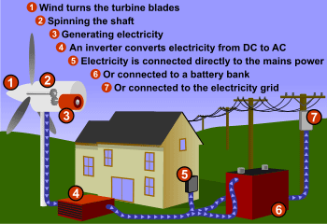The most common wind electricity-generating method is using wind turbines. **The wind turns large turbine blades, which spins a generator shaft and produces electricity** (more about the [parts of a wind turbine](http://exploringgreentechnology.com/wind-energy/parts-of-a-wind-turbine/))

The electricity can then **charge batteries**, be connected to a **building’s mains power**, or connected to the **national power grid**.

Wind turbines come in all shapes and sizes, from [large scale wind farms](http://exploringgreentechnology.com/wind-energy/top-wind-energy-companies/#biggest) to small scale wind turbines used to power a single   
home or business.

**How does wind energy work?** A wind turbine is connected to a house, battery bank, and/or the state electricity grid.

Like solar, the **European Union is leading the way with 48 percent of the world’s installed wind power capacity**. In 2009, wind turbines installed in the EU produced **163 TWh of electricity** – avoiding 106 million tonnes of carbon emissions [1].

Residential wind options include [small wind turbines](http://exploringgreentechnology.com/wind-energy/top-wind-energy-companies/#small-wind-turbines) such as 500w rated turbine generators – enough to run lighting or a few appliances – to larger scale turbines such as a 2kw rated – enough to power an entire house plus sell some to the national grid depending on how much you use.

The most common model is the **blade turbine**, however a new style of turbine has recently emerged – **vertical axis turbines**.

Vertical axis turbines are smaller, lower to the ground, and create less noise – so are good for residential areas.

The praticalities of how wind energy works is simple, but [socially](http://exploringgreentechnology.com/wind-energy/assessing-locations-for-wind-power-generation/#social) and [economically](http://exploringgreentechnology.com/wind-energy/assessing-locations-for-wind-power-generation/#economics), not so simple.

# The debates for and against wind power

# The main hindrance to wind power’s proliferation is the capital costs. Wind turbines are large and cost a lot of money to construct. They also require a reasonable amount of land, which is another expense that makes this free energy not so free.

# Interfering with the aesthetics of the land is another issue with wind turbines. The ideal location for a wind turbine is often rural and natural landscapes. Just as any issue of social policy, some people don’t mind seeing wind turbines out their front window, and some do.

# Another issue with wind power is that wind is intermittent. It’s not windy all the time in every location, so wind power production doesn’t happen around the clock. The true power of wind energy is positioned as a contributing piece to the clean energy puzzle.

# A secondary cost consideration is savings on carbon taxes and Emissions Trading Schemes – which are set at a per kg amount. A report on the New Zealand wind energy economy states that increasing wind energy installations to supply 20% of the country’s electricity needs will mean nationwide savings of $390 per person per year – based on production and carbon-tax reductions. [2]

# An interesting discussion is the cost of developing clean energy technologies – and the lack of commercial viability compared to conventional energy such as coal or nuclear. An interesting fact to note is that early nuclear development was subsidised by approximately $19/ kilowatt hour. Early wind technology worldwide was subsidised at approximately $0.57 / kilowatt hour.

# Unlike conventional energy production, wind is infinite and it doesn’t produce any toxic by-products such as carbon or ethane.

# It also doesn’t require any ongoing raw resources, which are expensive in terms of energy used for extraction, pollution from extraction and transportation, as well as financial costs of equipment and ongoing labour hours.

## How Does Wind Energy Work – How much electricity can a turbine produce?

Electricity output depends on a number of variables including location (how much wind there is), turbine size and style, and rotar diameter.  
 **Wind turbines have a rated capacity** – how much electricity they will produce at optimal wind speeds. A 2kW rated wind turbine will produce 2 kWh of electricity for every hour it’s exposed to optimal wind.

Generally, residential wind turbines are designed to function with **wind speeds between 11 and 15 meters per second** [3]. Larger turbines are often positioned in high wind-exposure locations, so are designed to function at higher wind speeds – thus producing more electricity.

Because of the intermittent nature of wind, general guidelines are that wind turbines will **output between 10-40% of their** [**rated capacity**](http://exploringgreentechnology.com/glossary/installed-capacity-definition/) [3].

A realistic estimate of how much electricity a wind turbine would produce can be calculated using the average wind speed and hours for your location and turbine model specifications.You can calculate this yourself, or a local dealer will have all the measurements.

In summing up, wind is a low cost, low maintenance energy production method. Wind energy works by harnessing natural wind movements, capturing it as kinetic energy through turbine blades, then converting the kinetic energy into electricity through an electro magnetic generator at the top of the turbine.

**References**

[1] European Wind Energy Association (EWEA). (2011). Statistics and targets.

[2] Infometrics Ltd. (2011). The potential contribution of wind generation to the economy: Report to New Zealand Wind Energy Association.

# [3] Energy Efficiency and Conservation Authority (EECA). (retrieved 2011). Small Wind Turbines. Retrieved from http://www.energywise.govt.nz/how-to-be-energy-efficient/generating-renewable-energy-at-home/small-wind-turbines#the

**Source G**

<http://www.legislature.mi.gov/documents/2011-2012/billintroduced/House/htm/2011-HIB-4499.htm>

(Source: Michigan House of Representatives)  
(Source Notes: According to website, bill was introduced in March 2011, but there has been no further action of this bill (i.e. has not been approved in either the MI House or MI Senate)).

**HOUSE BILL No. 4499**

March 24, 2011, Introduced by Reps. Franz and Bumstead and referred to the Committee on Energy and Technology.

     A bill to amend 1994 PA 451, entitled

"Natural resources and environmental protection act,"

by amending sections 32503 and 32512 (MCL 324.32503 and 324.32512),

section 32503 as amended by 2004 PA 325 and section 32512 as

amended by 2003 PA 14.

THE PEOPLE OF THE STATE OF MICHIGAN ENACT:

     Sec. 32503. (1) Except as otherwise provided in this section,

the department, after finding that the public trust in the waters

will not be impaired or substantially affected, may enter into

agreements pertaining to waters over and the filling in of

submerged patented lands, or to lease or deed unpatented lands,

after approval of the state administrative board. Quitclaim deeds,

leases, or agreements covering unpatented lands may be issued or

entered into by the department with any person, and shall contain

such terms, conditions, and requirements as the department

determines to be just and equitable and in conformance with the

public trust. The department shall reserve to the state all mineral

rights, including, but not limited to, coal, oil, gas, sand,

gravel, stone, and other materials or products located or found in

those lands, except where lands are occupied or to be occupied for

residential purposes at the time of conveyance.

     (2) A riparian owner shall not dredge or place spoil or other

materials on bottomland except as authorized by a permit issued by

the department pursuant to part 13.

     (3) The department shall not enter into a lease or deed that

allows drilling operations beneath unpatented lands for the

exploration or production of oil or gas.

     (4) The department shall not enter into a lease or deed that

allows the use of unpatented lands for the siting, placement,

construction, operation, or maintenance of any structure to

research wind energy development, any wind turbine, or any

equipment or structure related to a wind turbine, including, but

not limited, to a transmission line.

     (5) ~~(4)~~ An agreement, lease, or deed entered into under this

part by the department with the United States shall be entered into

and executed pursuant to the property rights acquisition act, 1986

PA 201, MCL 3.251 to 3.262.

     Sec. 32512. (1) Unless a permit has been granted by the

department or authorization has been granted by the legislature, or

except as to boat wells and slips facilitating private,

noncommercial, recreational boat use, not exceeding 50 feet in

length where the spoil is not disposed of below the ordinary high-

water mark of the body of water to which it is connected, a person

shall not do any of the following:

     (a) Construct, dredge, commence, or do any work with respect

to an artificial canal, channel, ditch, lagoon, pond, lake, or

similar waterway where the purpose is ultimate connection of the

waterway with any of the Great Lakes, including Lake St. Clair.

     (b) Connect any natural or artificially constructed waterway,

canal, channel, ditch, lagoon, pond, lake, or similar waterway with

any of the Great Lakes, including Lake St. Clair, for navigation or

any other purpose.

     (c) Dredge or place spoil or other material on bottomland.

     (d) Construct a marina.

~~(2) Notwithstanding subsection (1), and with respect to lands~~

~~covered and affected by this part, a permit or other approval is~~

~~not required under this part for either of the following:~~

~~(a) Until November 1, 2007, beach maintenance activities that~~

~~meet all of the following conditions:~~

~~(~~*~~i~~*~~) The activities shall not occur in environmental areas and~~

~~shall not violate part 365 or rules promulgated under that part, or~~

~~the endangered species act of 1973, Public Law 93-205, 87 Stat.~~

~~884, or rules promulgated under that act.~~

~~(~~*~~ii~~*~~) The width of any mowing of vegetation shall not exceed the~~

~~width of the riparian property or 100 feet, whichever is less.~~

~~(~~*~~iii~~*~~) All collected debris shall be disposed of properly outside~~

~~of any wetland.~~

~~(b) Until 3 years after the effective date of the amendatory~~

~~act that added this subdivision, removal of vegetation as~~

~~authorized in section 32516.~~

     (2) The department shall not grant a permit under this part

for the siting, placement, construction, operation, or maintenance

of any structure to research wind energy development, any wind

turbine, or any equipment or structure related to a wind turbine,

including, but not limited to, a transmission line.

**sOURCE H**

http://www.michigan.gov/documents/mpsc/wind_map_407661_7.pdf

Copyright © 2001-2013 State of Michigan

(Source: Michigan Public Service Commission, Department of Licensing and Regulatory Affairs)

